Pencillin Problem

1. Plot:

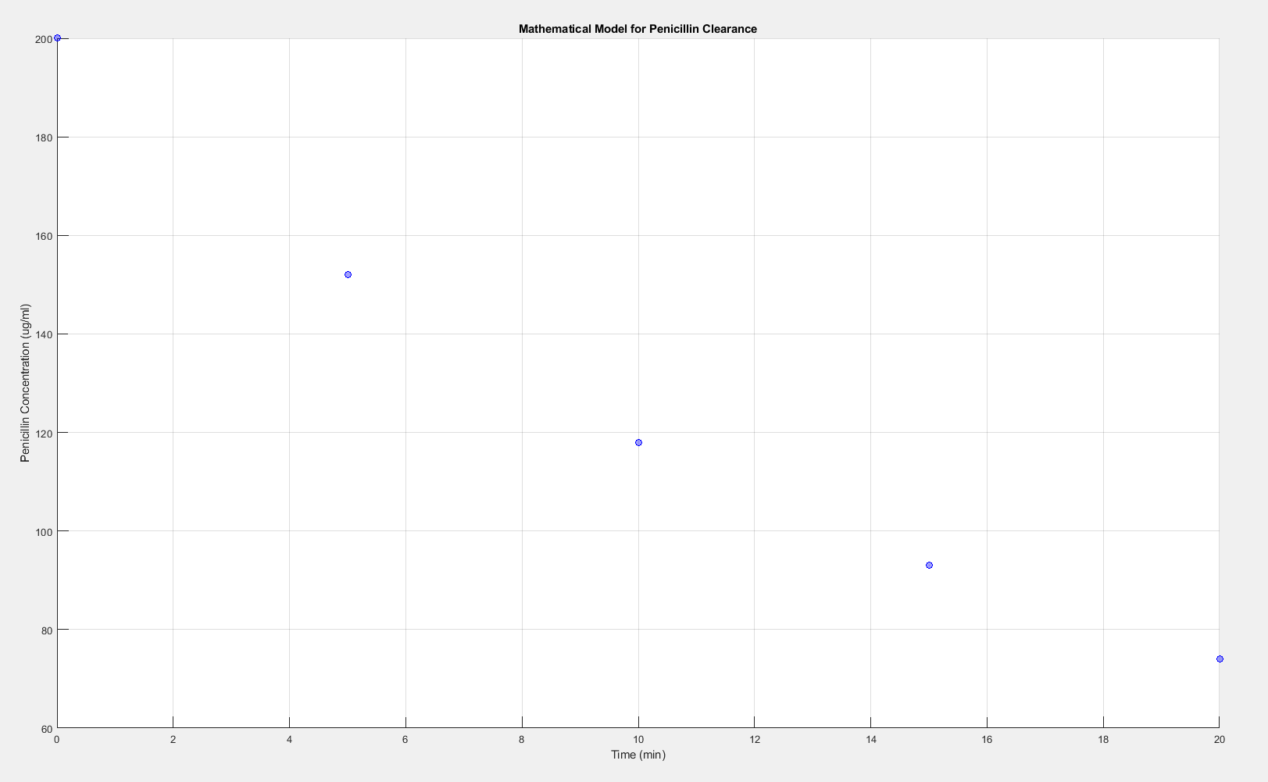

Code:

hold all

grid on

%Setting the x-axis domain

x=linspace(0,20,101)

%Setting the x-coordinate points

xpts=[0,5,10,15,20]

%Setting the y-coordinate points

ypts=[200,152,118,93,74]

%Plot the points

plot(xpts,ypts,'bo')

%Labelling the y-axis

ylabel ('Penicillin Concentration (ug/ml)')

%Labelling the x-axis

xlabel ('Time (min)')

%Labelling the Title

title ('Mathematical Model for Penicillin Clearance')

1. Plot:

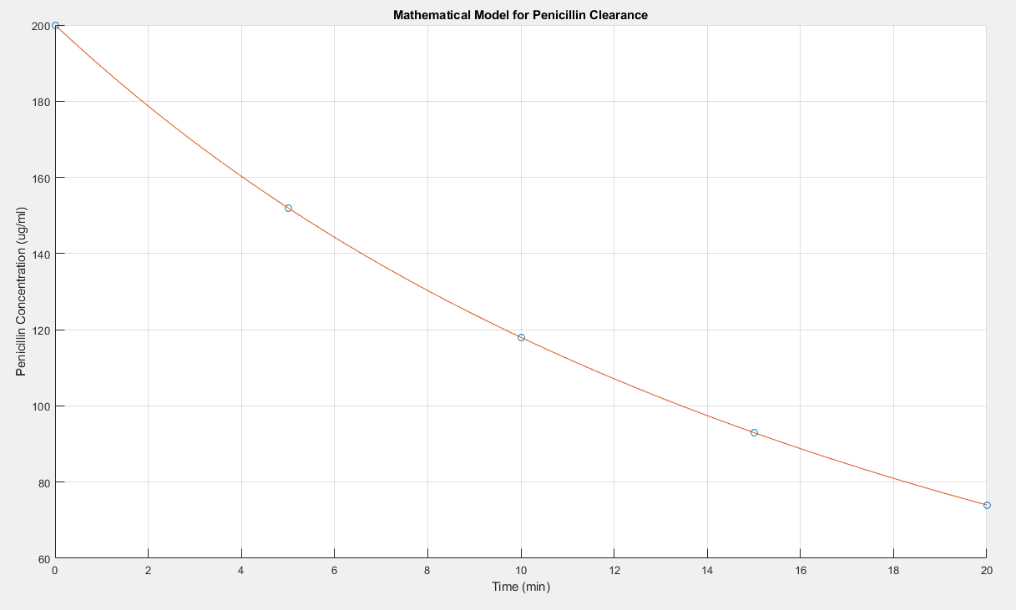

Code:

hold all

grid on

%Setting the x-axis domain

x=linspace(0,20,101)

%Setting the x-coordinate points

xpts=[0,5,10,15,20]

%Setting the y-coordinate points

ypts=[200,152,118,93,74]

%Plot the points

plot(xpts,ypts,'o')

%Labelling the y-axis

ylabel ('Penicillin Concentration (ug/ml)')

%Labelling the x-axis

xlabel ('Time (min)')

%Labelling the Title

title ('Mathematical Model for Penicillin Clearance')

x=linspace(0,20,101)

%Finding the coefficients

coefs=polyfit(xpts,ypts,4)

y=polyval(coefs,x)

%Plot the polynomial fit

plot(x,y)

c)Plot:

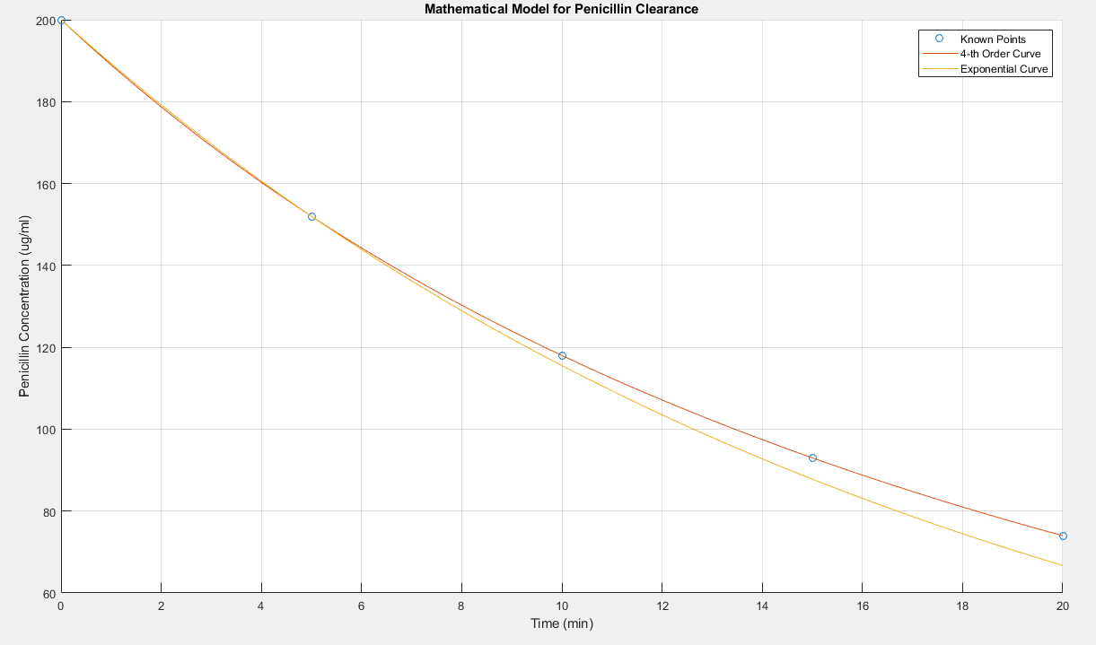

Code:

hold all

grid on

%Setting the x-axis domain

x=linspace(0,20,101)

%Setting the x-coordinate points

xpts=[0,5,10,15,20]

%Setting the y-coordinate points

ypts=[200,152,118,93,74]

%Plot the points

plot(xpts,ypts,'o')

%Labelling the y-axis

ylabel ('Penicillin Concentration (ug/ml)')

%Labelling the x-axis

xlabel ('Time (min)')

%Labelling the Title

title ('Mathematical Model for Penicillin Clearance')

x=linspace(0,20,101)

%Finding the coefficients

coefs=polyfit(xpts,ypts,4)

%Setting up the y-axis for the polynomial fit

y=polyval(coefs,x)

%Plot the polynomial fit

plot(x,y)

%Create function for the exponential curve

y1=200.\*exp(-0.05488736914.\*x)

%Plot exponential curve

plot(x,y1)

%Name legend

legend ('Known Points', '4-th Order Curve', 'Exponential Curve')

1. The exponential function done in part c is a better fit for this data as although it doesn’t encapsulate all of the data points, it continues to decrease exponentially over time whereas the polyval function increases. Thus, it is a more realistic fit while the the exponential fit goes slightly below the data points.
2. i) Plot: 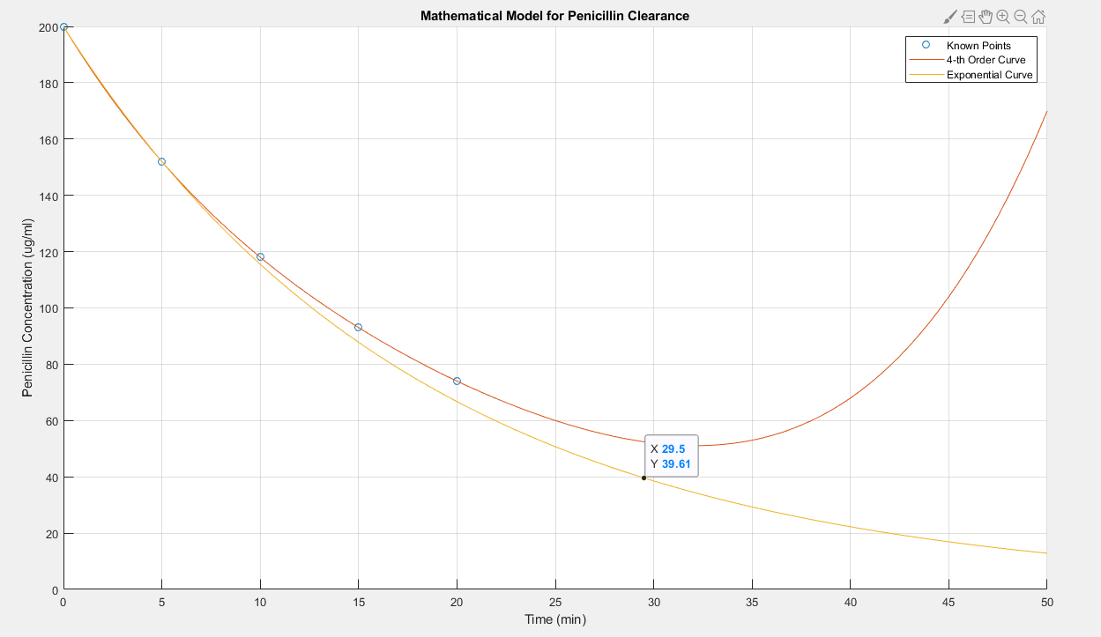

Add:

syms x

xsolns=solve(a\*e.^(b\*x)==40)

Therefore, at approximately 29.5 minutes, the penicillin concentration goes below 40 micrograms per milliliter.

ii) Plot:

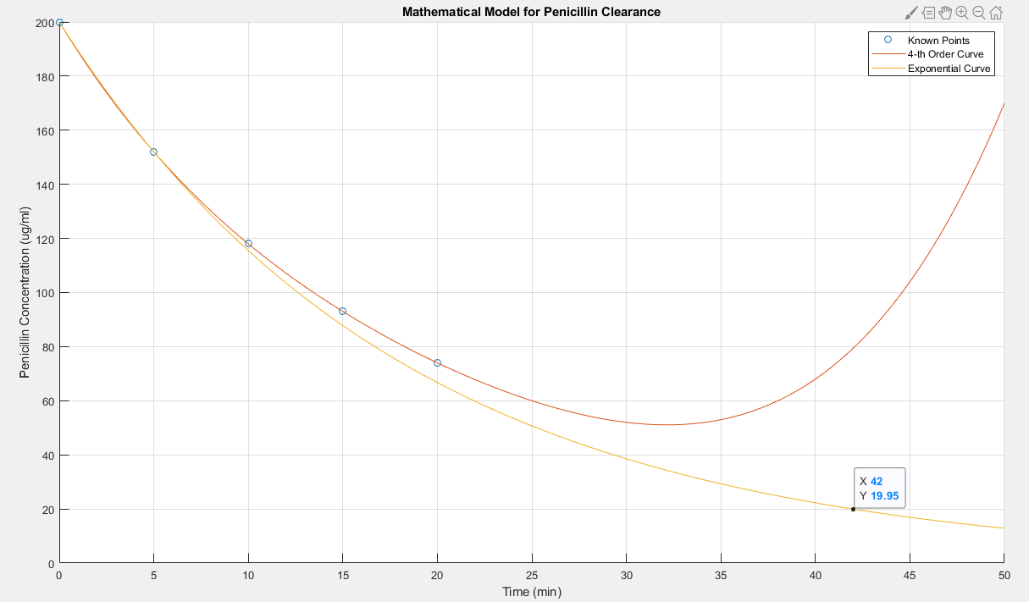

Therefore, the longest time that someone should wait is approximately 42 minutes.

1. MatLab was extremely effective in the activities done above. It allowed me to check which order function the data points followed. MatLab is effective in graphing two graphs on one axes. MatLab’s feature that allows graphs to be plotted with either points or functions can help one plot very easily. It allowed me to visualize both the fourth order and exponential curve at the same time. Adjusting the domain of the x-axis (time in minutes) by adjusting the x=linspace(0,20,101) allowed me to visualize which function is a better representation of the data points. Furthermore, I was able to use MatLab command window to help me deduce the *a* and *b* values in the exponential equation. Overall, I feel that MatLab was imperative in helping me plot, visualize, and extrapolate through this lab.